Device Driver_양영식

NXSOL-OJT-2024

Exported on 2024-02-23 13:40:14

Table of Contents

1 INDEX 3

2 0. UPDATE HISTORY 4

3 1. Introduction 5

4 2. Implemented features 6

4.1 2.1 Feature list 6

4.2 2.2 Command manual 6

4.3 2.3 Flow diagram 6

5 3. Target GPIO pins 7

6 4. Source 8

6.1 4.1 Source code 8

6.2 4.2 Add the source code 11

6.3 4.3 Existing APIs used in the source code 11

7 5. Test 12

7.1 5.1 Test scenario 12

7.2 5.2  Test code 13

7.3 5.3 Run test 17

7.4 5.4 Test result 17

8 Reference 20

# INDEX

* INDEX
* 0. UPDATE HISTORY
* 1. Introduction
* 2. Implemented features
  + 2.1 Feature list
  + 2.2 Command manual
  + 2.3 Flow diagram
* 3. Target GPIO pins
* 4. Source
  + 4.1 Source code
  + 4.2 Add the source code
  + 4.3 Existing APIs used in the source code
* 5. Test
  + 5.1 Test scenario
  + 5.2 Test code
  + 5.3 Run test
  + 5.4 Test result
* Reference

# 0. UPDATE HISTORY

|  |  |  |  |
| --- | --- | --- | --- |
| **EVENT** | **Date** | **Description** | **Author** |
| create | 2024.2.20 | create | NXKR_YoungSikYang |
| modify | 2024.2.21 | modified the contents according to the template | NXKR_YoungSikYang |
| modify | 2024.2.21 | * corrected wrong indentation * added source code * added gpio-uclass.c reference | NXKR_YoungSikYang |
| modify | 2024.2.22 | * modified implemented features * deleted memory location * modified test scenario | NXKR_YoungSikYang |
| modify | 2024.2.23 | * Modified command manual so that it can be clearer * Corrected a typo in flow diagram * Added more explanation to each section | NXKR_YoungSikYang |

# 1. Introduction

* Final assignment of u-boot training.
* Board: BTC08(s5p6818)

Utilizing the GPIO device driver implemented in gpio-uclass.c, I have developed features as specified in the assignment requirements and tested them using u-boot commands.

# 2. Implemented features

The features are related to controlling or querying GPIOs.

## 2.1 Feature list

The features can be classified into 3 categories

* GPIO input/output (GPIOA, GPIOB, GPIOC, GPIOD, GPIOE)
* LED control (AP_LED0, AP_LED1)
* Button detection (AP_KEY0)

## 2.2 Command manual

|  |  |
| --- | --- |
| Command | Action |
| nx_gpio led <on|off> | Turn the LEDs on or off |
| nx_gpio <set|clear|toggle|get> <num> | set|clear|toggle|get <num> GPIO |
| nx_gpio btn | Wait for button presss and toggle the LEDs |

## 2.3 Flow diagram

This diagram visualizes the behavior of each command.

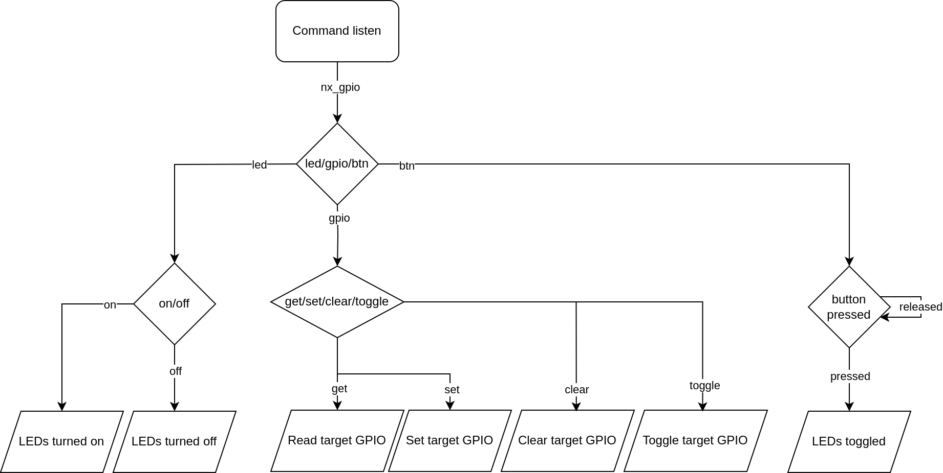

# 3. Target GPIO pins

This picture is from Page 6 of tsb1101_control_v100_rel_20181126.pdf

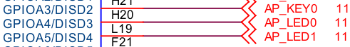

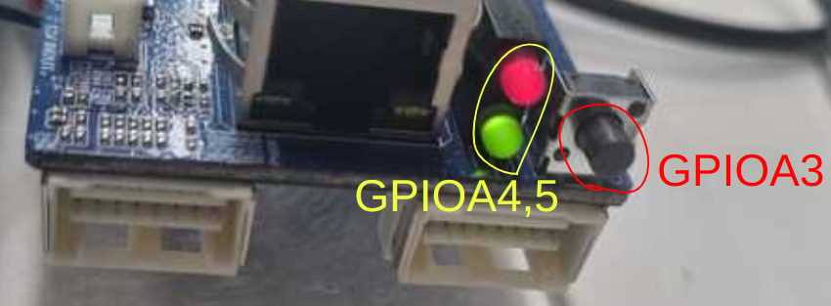

# 4. Source

## 4.1 Source code

|  |
| --- |
| #include <common.h>  #include <command.h>  #include <stdarg.h>  #include <errno.h>  #include <dm.h>  #include <asm/gpio.h>    #define BTN 3  #define LED0 4  #define LED1 5  #define ON 0  #define OFF 1    **static** int gpios_toggle(int gpio, ...)  {  va_list args;  va_start(args, gpio);  int ret;  **while** (gpio != -1) {  **if** (gpio_request(gpio, "cmd_nx_gpio")) {  printf("Failed to request gpio %i\n", gpio);  **return** -1;  }  ret = gpio_get_value(gpio);  **if** (ret < 0) {  printf("Failed to get gpio %i value\n", gpio);  gpio_free(gpio);  **return** ret;  }  ret = gpio_set_value(gpio, !ret);  **if** (ret < 0) {  printf("Failed to toggle gpio %i value\n", gpio);  gpio_free(gpio);  **return** ret;  }  printf("gpio %i value is %d\n", gpio, !ret);  gpio_free(gpio);  gpio = va_arg(args, int);  }  va_end(args);  **return** ret;  }    **static** int gpios_set_value(int gpio_value, int gpio, ...)  {  va_list args;  va_start(args, gpio);  int ret;  **while** (gpio != -1) {  **if** (gpio_request(gpio, "cmd_nx_gpio")) {  printf("Failed to request gpio %i\n", gpio);  **return** -1;  }  ret = gpio_set_value(gpio, gpio_value);  **if** (ret < 0) {  printf("Failed to set gpio %i value\n", gpio);  gpio_free(gpio);  **return** ret;  }  printf("gpio %i value is %d\n", gpio, gpio_value);  gpio_free(gpio);  gpio = va_arg(args, int);  }  va_end(args);  **return** ret;  }    int do_nx_gpio(cmd_tbl_t *cmdtp, int flag, int argc, char * **const** argv[])  {  int gpio_value, gpio, ret;  /* Not enough args */  **if** (argc < 2) {  printf("Usage: %s\n", cmdtp->usage);  **return** CMD_RET_FAILURE;  }    **if** (strcmp(argv[1], "led") == 0) {  **if** (argc < 3) {  printf("Usage: %s\n", cmdtp->usage);  **return** CMD_RET_FAILURE;  }  **if** (strcmp(argv[2], "on") == 0) {  **if** (gpios_set_value(ON, LED0, LED1, -1))  **return** CMD_RET_FAILURE;  } **else** **if** (strcmp(argv[2], "off") == 0) {  **if** (gpios_set_value(OFF, LED0, LED1, -1))  **return** CMD_RET_FAILURE;  } **else** {  printf("Usage: %s\n", cmdtp->usage);  **return** CMD_RET_FAILURE;  }  } **else** **if** (strcmp(argv[1], "gpio") == 0) {  **if** (argc < 4) {  printf("Usage: %s\n", cmdtp->usage);  **return** CMD_RET_FAILURE;  }  ret = gpio_lookup_name(argv[3], NULL, NULL, &gpio);  **if** (gpio < 0) {  printf("Usage: %s\n", cmdtp->usage);  **return** CMD_RET_FAILURE;  }  **if** (strcmp(argv[2], "get") == 0) {  **if** (gpio_request(gpio, "cmd_nx_gpio")) {  printf("Failed to request gpio %i\n", gpio);  **return** CMD_RET_FAILURE;  }  gpio_value = gpio_get_value(gpio);  **if** (gpio_value < 0) {  printf("Failed to get gpio %i value\n", gpio);  gpio_free(gpio);  **return** CMD_RET_FAILURE;  }  printf("gpio %i value is %d\n", gpio, gpio_value);  gpio_free(gpio);  } **else** **if** (strcmp(argv[2], "set") == 0) {  **if** (gpios_set_value(1, gpio, -1))  **return** CMD_RET_FAILURE;  } **else** **if** (strcmp(argv[2], "clear") == 0) {  **if** (gpios_set_value(0, gpio, -1))  **return** CMD_RET_FAILURE;  } **else** **if** (strcmp(argv[2], "toggle") == 0) {  **if** (gpios_toggle(gpio, -1))  **return** CMD_RET_FAILURE;  } **else** {  printf("Usage: %s\n", cmdtp->usage);  **return** CMD_RET_FAILURE;  }  } **else** **if** (strcmp(argv[1], "btn") == 0) {  printf("Waiting for button press...\n");  **if** (gpio_request(BTN, "cmd_nx_gpio")) {  printf("Failed to request gpio %i\n", gpio);  **return** CMD_RET_FAILURE;  }  /* Polling */  **while** (1) {  gpio_value = gpio_get_value(BTN);  **if** (gpio_value < 0) {  printf("Failed to get gpio %i value\n", 3);  gpio_free(BTN);  **return** CMD_RET_FAILURE;  }  **if** (gpio_value == 0) {  gpio_free(BTN);  **break**;  }  }  /* Toggle LEDs */  **if** (gpios_toggle(LED0, LED1, -1))  **return** CMD_RET_FAILURE;  } **else** {  printf("Usage: %s\n", cmdtp->usage);  **return** CMD_RET_FAILURE;  }  **return** CMD_RET_SUCCESS;  }    U_BOOT_CMD(nx_gpio, 4, 0, do_nx_gpio,  "Query and control gpio pins",  "\n- led on|off: Turn the LEDs on|off\n"  "- gpio set|clear|toggle|get <num>: Set|Clear|Toggle|Get <num> gpio\n"  "- btn: Wait for button press and toggle 2 LEDs\n"  ); |

Code Block 1 common/cmd_nx_gpio.c

## 4.2 Add the source code

Configure so that the new source code can be compiled and included in u-boot through the build process.

common/Makefile

This adds the source to the compile list.



common/kconfig

This includes the source in u-boot.

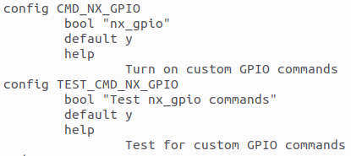

And then build

## 4.3 Existing APIs used in the source code

The source code above takes advantage of this API source

https://github.com/NexellCorp/u-boot-2016.01/blob/artik/drivers/gpio/gpio-uclass.c

# 5. Test

Each command is tested by visually checking the color of the LEDs and verifying the input of the target GPIO through the GPIO driver.

## 5.1 Test scenario

|  |  |  |  |
| --- | --- | --- | --- |
| Case | Command | Expectation | Goal |
| get GPIOA3 | nx_gpio gpio get 3 | GPIOA3 is high with button released → button press -> GPIOA3 is low | GPIO input works |
| led off | nx_gpio led off | LEDs are on → LEDs are turned off | LED on/off works |
| led on | nx_gpio led on | LEDs are off → LEDs are turned on | LED on/off works |
| led abc | nx_gpio led abc | Command does not work (invalid command) | Invalid command does not work |
| set GPIOA4,5 | nx_gpio gpio set 4  nx_gpio gpio set 5 | GPIOA4,5 are 0 → GPIOA4,5 are set to 1(LEDs are turned off) | GPIO output works |
| clear GPIOA4,5 | nx_gpio gpio clear 4  nx_gpio gpio clear 5 | GPIOA4,5 are 1 → GPIOA4,5 are cleared to 0(LEDs are turned on) | GPIO output works |
| toggle GPIOA4,5 | nx_gpio gpio toggle 4  nx_gpio gpio toggle 5 | GPIOA4,5 are 0 → GPIOA4,5 are toggled to 1(LEDs are turned off) | GPIO output works |
| toggle GPIOA4,5 on button press | nx_gpio btn | GPIOA4,5 are 1 → button press -> GPIOA4,5 are toggled to 0(LEDs are turned on) | GPIO output works |

## 5.2  Test code

|  |
| --- |
| #include <common.h>  #include <command.h>  #include <errno.h>  #include <dm.h>  #include <asm/gpio.h>    **static** **void** gpio_get(unsigned int *total_tests, unsigned int *passed_tests)  {  printf("Test: gpio get\n");  *total_tests += 1;  /* Given: button connected to GPIO 3 is released */  /* When: check the value of GPIO 3 */  gpio_request(3, "cmd_nx_gpio");  char gpio_value = gpio_get_value(3);  /* Then: GPIO 3 is high */  **if** (gpio_value == 1)  printf("GPIO 3 is high.(released)\n");  **else** {  printf("Test failed: GPIO 3 is not high.\n");  **return**;  }  printf("Waiting for button press...\n");  /* Given: button connected to GPIO 3 is released */  /* When: button is pressed */  **while** (1) {  gpio_value = gpio_get_value(3);  **if** (gpio_value == 0)  **break**;  }  /* Then: GPIO 3 is low */  **if** (gpio_get_value(3) == 0) {  printf("Test passed: GPIO 3 is low.(pressed)\n");  ++*passed_tests;  } **else**  printf("Test failed: GPIO 3 is not low.\n");  gpio_free(3);  }    **static** **void** led_off(unsigned int *total_tests, unsigned int *passed_tests)  {  printf("Test: led off\n");  *total_tests += 1;  /* Given: LEDs are on */  /* When: turn off the LEDs */  run_command("nx_gpio led off", 0);  /* Then: GPIO 4 and 5 are high */  gpio_request(4, "cmd_nx_gpio");  gpio_request(5, "cmd_nx_gpio");  **if** (gpio_get_value(4) == 1 && gpio_get_value(5) == 1) {  printf("Test passed: LEDs off.\n");  ++*passed_tests;  } **else**  printf("Test failed: LEDs are not off.\n");  gpio_free(4);  gpio_free(5);  }    **static** **void** led_on(unsigned int *total_tests, unsigned int *passed_tests)  {  printf("Test: led on\n");  *total_tests += 1;  /* Given: LEDs are off */  /* When: turn on the LEDs */  run_command("nx_gpio led on", 0);  /* Then: GPIO 4 and 5 are low */  gpio_request(4, "cmd_nx_gpio");  gpio_request(5, "cmd_nx_gpio");  **if** (gpio_get_value(4) == 0 && gpio_get_value(5) == 0) {  printf("Test passed: LEDs on.\n");  ++*passed_tests;  } **else**  printf("Test failed: LEDs are not on.\n");  gpio_free(4);  gpio_free(5);  }    **static** **void** led_abc(unsigned int *total_tests, unsigned int *passed_tests)  {  int ret;  printf("Test: led abc\n");  *total_tests += 1;  /* Given: LEDs are off */  /* When: turn on the LEDs */  ret = run_command("nx_gpio led abc", 0);  /* Then: Invalid command */  **if** (ret == 1) {  printf("Test passed: Invalid command.\n");  ++*passed_tests;  } **else** **if** (ret == 0)  printf("Test failed: Command not invalid.\n");  }    **static** **void** gpio_set(unsigned int *total_tests, unsigned int *passed_tests)  {  printf("Test: gpio set\n");  *total_tests += 1;  /* Given: LEDs are on */  /* When: setting GPIO 4 and 5 */  run_command("nx_gpio gpio set 4", 0);  run_command("nx_gpio gpio set 5", 0);  /* Then: LEDs are off */  gpio_request(4, "cmd_nx_gpio");  gpio_request(5, "cmd_nx_gpio");  **if** (gpio_get_value(4) == 1 && gpio_get_value(5) == 1) {  printf("Test passed: GPIO 4 and 5 set.\n");  ++*passed_tests;  } **else**  printf("Test failed: GPIO 4 and 5 are not set.\n");  gpio_free(4);  gpio_free(5);  }    **static** **void** gpio_clear(unsigned int *total_tests, unsigned int *passed_tests)  {  printf("Test: gpio clear\n");  *total_tests += 1;  /* Given: LEDs are off */  /* When: clear GPIO 4 and 5 */  run_command("nx_gpio gpio clear 4", 0);  run_command("nx_gpio gpio clear 5", 0);  /* Then: LEDs are on */  gpio_request(4, "cmd_nx_gpio");  gpio_request(5, "cmd_nx_gpio");  **if** (gpio_get_value(4) == 0 && gpio_get_value(5) == 0) {  printf("Test passed: GPIO 4 and 5 cleared.\n");  ++*passed_tests;  } **else**  printf("Test failed: GPIO 4 and 5 are not cleared.\n");  gpio_free(4);  gpio_free(5);  }    **static** **void** gpio_toggle(unsigned int *total_tests, unsigned int *passed_tests)  {  printf("Test: gpio toggle\n");  *total_tests += 1;  /* Given: initial state of GPIO 4 and 5 */  gpio_request(4, "cmd_nx_gpio");  gpio_request(5, "cmd_nx_gpio");  char gpio4_value = gpio_get_value(4);  char gpio5_value = gpio_get_value(5);  gpio_free(4);  gpio_free(5);  /* When: toggle GPIO 4 and 5 */  run_command("nx_gpio gpio toggle 4", 0);  run_command("nx_gpio gpio toggle 5", 0);  gpio_free(4);  gpio_free(5);  /* Then: GPIO 4 and 5 are toggled */  gpio_request(4, "cmd_nx_gpio");  gpio_request(5, "cmd_nx_gpio");  **if** (gpio4_value != gpio_get_value(4)  && gpio5_value != gpio_get_value(5)) {  printf("Test passed: GPIO 4 and 5 toggled.\n");  ++*passed_tests;  } **else**  printf("Test failed: GPIO 4 and 5 are not toggled.\n");  gpio_free(4);  gpio_free(5);  }    **static** **void** btn(unsigned int *total_tests, unsigned int *passed_tests)  {  printf("Test: btn\n");  *total_tests += 1;  /* Given: initial state of GPIO 4 and 5 /  the button connected to GPIO 3 is released */  gpio_request(4, "cmd_nx_gpio");  gpio_request(5, "cmd_nx_gpio");  char gpio4_value = gpio_get_value(4);  char gpio5_value = gpio_get_value(5);  gpio_free(4);  gpio_free(5);  /* When: wait for button to be pressed */  run_command("nx_gpio btn", 0);  /* Then: LEDs are toggled */  gpio_request(4, "cmd_nx_gpio");  gpio_request(5, "cmd_nx_gpio");  **if** (gpio4_value != gpio_get_value(4) &&  gpio5_value != gpio_get_value(5)) {  printf("Button pressed and LEDs toggled.\n");  ++*passed_tests;  } **else**  printf("Button press not recognized or LEDs not toggled.\n");  gpio_free(4);  gpio_free(5);  }    **static** **void** run_test(**void** (*test)(unsigned int *, unsigned int *),  unsigned int *total_tests, unsigned int *passed_tests)  {  test(total_tests, passed_tests);  printf("Press any key for the next test...\n--------------\n");  **while** (!tstc())  ;  getc();  }    int do_test_nx_gpio(**void**)  {  unsigned int total_tests = 0;  unsigned int passed_tests = 0;  run_test(gpio_get, &total_tests, &passed_tests);  **if** (passed_tests == 0) /* Other tests depend on this one */  **return**;  run_test(led_off, &total_tests, &passed_tests);  run_test(led_on, &total_tests, &passed_tests);  run_test(led_abc, &total_tests, &passed_tests);  run_test(gpio_set, &total_tests, &passed_tests);  run_test(gpio_clear, &total_tests, &passed_tests);  run_test(gpio_toggle, &total_tests, &passed_tests);  btn(&total_tests, &passed_tests);  printf("--------------\n"  "Test completed. %u out of %u tests passed.\n",  passed_tests, total_tests);  **return** CMD_RET_SUCCESS;  }    U_BOOT_CMD(test_nx_gpio, 1, 0, do_test_nx_gpio,  "Test cmd_nx_gpio",  "\nRun tests for cmd_nx_gpio\n"  ", which include gpio get, led on|off, gpio set|clear|toggle, and btn\n"  ); |

Code Block 2 test/cmd_nx_gpio.c

## 5.3 Run test

|  |
| --- |
| $ test_nx_gpio |

## 5.4 Test result

The result table is below.

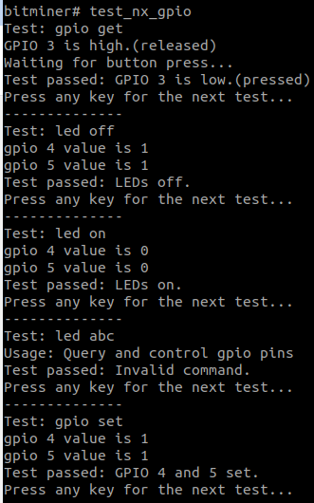

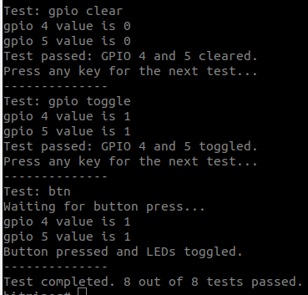

**Test result table**

* Pass: Test case worked as "expectation" of the test scenario table
* Fail: Test case did not work as "expectation" of the test scenario table

|  |  |
| --- | --- |
| Case | Result |
| get GPIOA3 input | Pass |
| led off | Pass |
| led on | Pass |
| led abc | Pass |
| set GPIOA4,5 | Pass |
| clear GPIOA4,5 | Pass |
| toggle GPIOA4,5 | Pass |
| toggle GPIOA4,5 on button press | Pass |

**LEDs  successfully turned on and off before and after each GPIO output command**

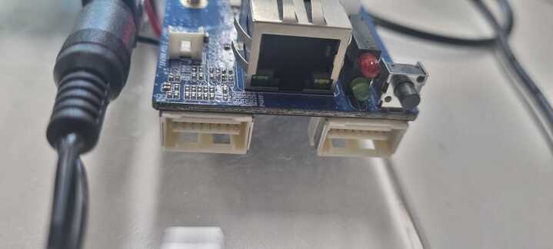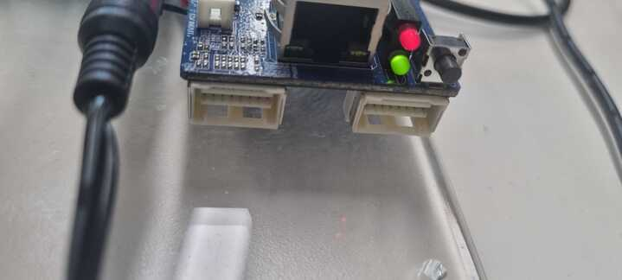

# Reference

* tsb1101_control_v100_rel_20181126.pdf
* S5P6818_Datasheet_Ver142A.pdf
* https://docs.u-boot.org/en/latest/
* https://github.com/NexellCorp/u-boot-2016.01